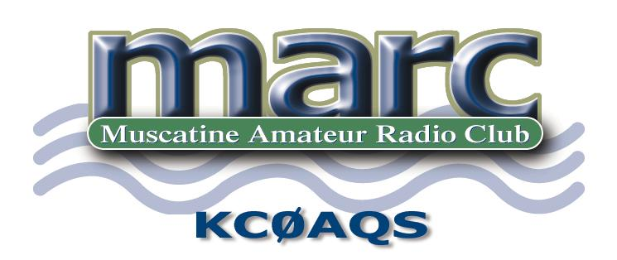
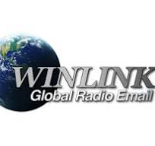
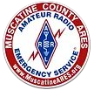
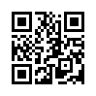
What is Winlink and how do I get involved?

Winlink Global Radio Email®️...
...is a network of amateur radio and authorized government stations that provide worldwide radio email using radio pathways where the internet is not present.
Many of our served agencies require Winlink as part of our support.
The most complete software for Winlink is Winlink Express, a Windows application, that is found at https://winlink.org/ The QR code in the logo will take you there. This software is free. You will also need VARA HF and/or VARA FM, also free. (For full speed, a one-time donation to the software author is required.)
You also need an HF SSB or VHF or above FM transceiver and a computer.
Depending on your radio, you may need a cable and you may need a sound card modem, such as a SignaLink or RigBlaster.
Some radios have a built-in sound card, needing only a cable or Bluetooth connection.
The Winlink system handles email, including all the regular email does, plus position reporting, weather bulletins, emergency and relief communications, and message relay between hams or SHARES (US Department of Homeland Security) users and can send email to regular, internet email addresses.
There are Wnlink nets every day of the week. Some nets run only part of a particular day, others run a whole day, weekend or week.
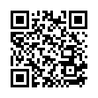
Iowa ARES® Winlink Weekend is the primary Iowa Winlink net.
https://iowawinlink.net/Saturday.php

